Atlantic Bay-Mountain Region 19

Sweet Adelines International, Inc.

Regional Faculty Guide

FY 2023
Updated 06/1/23

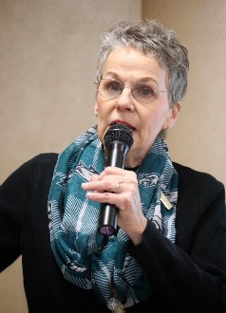
Linda Beaver
Email: Euphonixlead@gmail.com
Hometown: Secane, PA

Instructional Objectives: I always strive to impart a proactive understanding and
appreciation of the craft and performance of Barbershop Harmony.

Instructional Qualifications: Current Regional Faculty member, current Frontline Director

Chorus Affiliation(s): Diamond State (Rehearsal Night: Tuesdays)

Distance Willing to Travel: 0 – 50 miles

COACHING SKILLS:
SOUND
Blend and balance
Harmony accuracy and tuning
Riser placement
Unit sound
Using vocal skills to enhance expressions, emotion, storytelling
Using vocal textures
Vocal production

MUSIC
Arranging
Music selection

MUSIC STAFF MENTORING
Music staff training and development
Section leader training

VISUAL COMMUNICATION
Characterization
Getting it across the footlights
Show planning
Visual unity

OPEN DIVISION
Parody writing

GROUP MANAGEMENT
Effective communication
Getting your quartet started
Managing stage nerves
Motivating skills
Contract writing

TECHNOLOGY SKILLS
Database management

NANCY CLOETER
Email: Ncloeter@gmail.com
Hometown: Queenstown, MD

Instructional Objectives: My objectives are to quickly assess the level of the group I am coaching and try to find the areas in which they will get the best instruction that will give them the most help at their current level. I focus on all areas but my strengths are in vocal production, vocal placement, internal synchronization, and overall commitment to the message of the song.

Instructional Qualifications: Tenor Section leader for Ramapo Valley Chorus, Tenor section team leader for Harbor City Music Company, 1992 Queen of Harmony with City Lights, and 2004 Queen of Harmony with the BUZZ. In my 16 years with the BUZZ, I taught many music school classes which I developed, including, Tenor section classes, In-Line Singing, Connected Sound, and taught many classes along with the rest of The BUZZ. I have coached many quartets, including our current 6th place Intl finalists, Voce. I have also coached many choruses in Regions all over the world.

Chorus Affiliation(s): Harbor City Music Company (Rehearsal Night: Wednesdays)
Quartet Affiliation: The BUZZ

Distance Willing to Travel: 0 – 25 miles

COACHING SKILLS:
SOUND
Blend and balance
Dynamic planning
Harmony accuracy and tuning
Posture/breathing
PVI's
Unit sound
Using vocal skills to enhance expression, emotion, storytelling
Using vocal textures
Vocal production

VISUAL COMMUNICATION
Characterization
Getting it across the footlights
Visual unity

GROUP MANAGEMENT
Getting your quartet started
Goal setting/Long range planning
Managing stage nerves

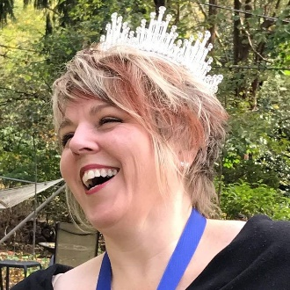
LORI CROUTER
Email: lorilcrouter@gmail.com
Hometown: Glen Burnie, MD

Instructional Objectives: I would like to help newer quartets feel comfortable on stage. Both with their singing and their presentation.

Instructional Qualifications: I have sung in a chorus & quartet with continued coaching for the last 18 years. I also have a degree in music education and a minor in theatre.

Chorus Affiliation(s): Harbor City Music Company (Rehearsal Night: Wednesdays)
Quartet Affiliation: Lustre (Rehearsal Night: Weekends)

Distance Willing to Travel: 0 – 50 miles

COACHING SKILLS:
SOUND
Harmony accuracy and tuning
Posture/breathing
PVI's
Using vocal textures
Vocal production

VISUAL COMMUNICATION
Characterization
Getting it across the footlights
Show planning
Visual unity

OPEN DIVISION
Emceeing
Timing
Unity

GROUP MANAGEMENT
Getting your quartet started

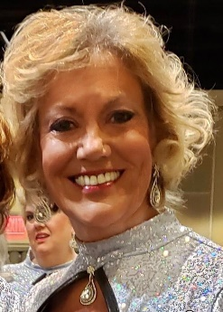
Claire Domenick
Email: Cdomenick@aol.com
Hometown: Malvern, PA

Instructional Objectives: To help singers understand the BBS craft and enjoy the process.

Instructional Qualifications:
- Master Director
- Regional Faculty
- International Mentor Faculty

Chorus Affiliation(s):
Quartet Affiliation:

Distance Willing to Travel: 0 – 75 miles

COACHING SKILLS:
SOUND
Blend and balance
Harmony accuracy and tuning
Posture/breathing
Riser placement
Unit sound
Vocal production

VISUAL COMMUNICATION
Characterization
Getting it across the footlights
Visual unity

GROUP MANAGEMENT
Chorus mediation

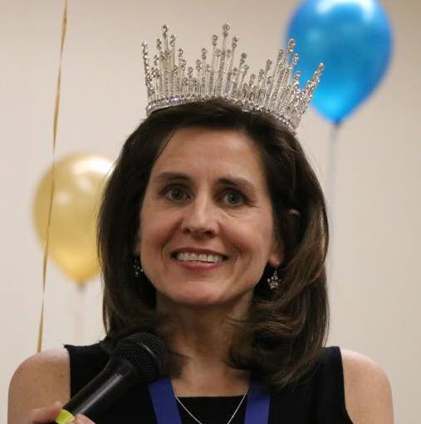
Lori Dreyer
Email: lorialto@comcast.net
Hometown: Baltimore, MD

Instructional Objectives: Encourage singers at all levels in choruses and quartets to
value and celebrate what they do well and then build on those strengths.

Provide a fun and nurturing environment in which we all collaborate to improve a
musical product.

My strongest capabilities are in the showmanship and expression categories, but do recognize and can help
with basic vocal production and freedom of sound.

Instructional Qualifications:
- Nearly 30 year member of SAI
- Active chorus member (Elkridge/HCMC) for nearly 30 years
- Long time baritone section leader, music team member, costume team member, creative team member
- Baritone of Lustre Quartet, 2018 Queens of Harmony
- Coaching Region 19 choruses and quartets on my own
- Coaching out of region choruses working as a coaching team with other members of Lustre

Chorus Affiliation(s): Harbor City Music Company (Rehearsal Night: Wednesdays)
Quartet Affiliation: Lustre (Rehearsal Night: Varies, typically Sunday afternoon)

Distance Willing to Travel: Doesn’t Matter

COACHING SKILLS:

SOUND GROUP MANAGEMENT
Posture/breathing Getting your quartet started
PVI's
Using vocal textures
Using vocal skills to enhance expression, emotion, storytelling
Vocal production

VISUAL COMMUNICATION TECHNOLOGY SKILLS
Choreography design & teaching Computer skills
Costumes
Characterization
Getting it across the footlights
Show planning
Visual unity

OPEN DIVISION
Category requirements
Entertainment themes
Emceeing
Humor
Parody writing
Script writing
Planning
Timing
Unity
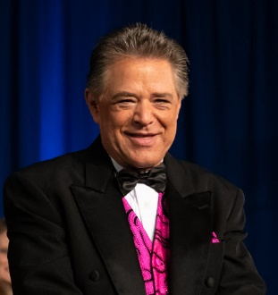
MICHAEL GELLERT
Email: mhgellert@hotmail.com
Hometown: Severna Park, MD

Instructional Objectives: For members to learn to use the vocal skills they already posess
to be better singers and performers. To instruct singers how to access their skills through their right brain.

Instructional Qualifications: Lifelong private individual study in vocal and choral arts. Twelve years private voice study. Forty-six years teaching private voice. Fifteen years professional theatre (Baltimore Opera). Twenty-nine years directing women’s barbershop/Harbor City). I’m a Master 700 Director in Region 19 with 12 Regional gold medals and 5 times finishing in the International Top 10.

Chorus Affiliation(s): Harbor City Music Company (Rehearsal Night: Wednesdays)

Distance Willing to Travel: Doesn’t Matter

COACHING SKILLS:
SOUND
Blend and balance
Dynamic planning
Harmony accuracy and tuning
Posture/breathing
PVI's
Unit sound
Using vocal textures
Using vocal skills to enhance expression, emotion, storytelling
Vocal production

MUSIC GROUP MANAGEMENT
Arranging Effective communication
Music selection Effective meetings
Music theory Getting your quartet started

MUSIC STAFF MENTORING Goal setting/Long range planning
Director skills training Managing stage nerves
How to give a PVI Membership
Music staff training and development Motivating skills
Rehearsal planning and management Team building & management
Section leader training

VISUAL COMMUNICATION
Characterization
Getting it across the footlights
Visual unity

OPEN DIVISION
Emceeing
Entertainment themes
Humor
Planning

Jenny Harris
Email: jennysingsbass@gmail.com
Hometown: Baltimore, MD

Instructional Objectives: Exploring artistry in our music. Bringing out confidence in members.

Instructional Qualifications: On the job (in Sweet Adelines Int.)

Chorus Affiliation(s): Harbor City Music Company, The Annapolis Blend (Rehearsal Nights: Tuesdays, Wednesdays)
Quartet Affiliation: Lustre Quartet (Rehearsal Night: Weekends (varies))

Distance Willing to Travel: Doesn’t Matter

COACHING SKILLS:
SOUND
Blend and balance
Dynamic planning
Harmony accuracy and tuning
Posture/breathing
PVI's
Unit sound
Using vocal skills to enhance expression, emotion, storytelling

MUSIC
Music selection

MUSIC STAFF MENTORING
Music staff training and development
Rehearsal planning and management
Section leader training

VISUAL COMMUNICATION
Characterization
Getting it across the footlights

OPEN DIVISION
Emceeing
Planning
Timing

GROUP MANAGEMENT
Getting your quartet started
Goal setting/Long range planning

ALEXANDRA HAUGER
Email: ali.hauger@gmail.com
Hometown: Baltimore, MD

Instructional Objectives: To assist choruses and quartets in finding the authentic
performer inside of them.

Instructional Qualifications: 15 year Sweet Adeline
3rd Place International quartet
2x Rising Star Champion
5x Region 19 Champion

Chorus Affiliation(s): (Rehearsal Night: Wednesdays)
Quartet Affiliation: GQ (Rehearsal Night: Thursday (adjustable))

Distance Willing to Travel: 0 – 75 miles

COACHING SKILLS:
SOUND
Blend and balance
Dynamic planning
Riser placement
Using vocal skills to enhance expression, emotion, storytelling

VISUAL COMMUNICATION
Characterization
Choreography design & teaching
Make-up
Show planning
Visual unity

GROUP MANAGEMENT
Chorus mediation
Effective communication
Effective meetings
Goal setting/Long range planning
Marketing/PR
Team building & management

RITCHIE LAVENE
Email: rlavene@comcast.net
Hometown: New Egypt, NJ

Instructional Objectives:
My coaching style is run through the following filter, looking for the performers:

Love of the music
Love of how we make the music
Love and empathy for each other
Love and empathy for anyone they sing for.

I try to always teach in “Discovery” mode creating opportunity and motivation to become empowered by their own musicianship. It’s a wholistic approach that takes all factors into account for the best possible delivery of the music and the story!

Instructional Qualifications:
Assistant Director From 1986-1995 (BHS)
Front Line Director From 1995-Present (BHS)
Director of The Jersey Sound, 2022-Present
Certified Director both BHS and SAI
Certified Performance Judge since 2000
Served Faculty for many District Schools across the country.

Chorus Affiliation(s): Jersey Sound Chorus (Rehearsal Night: Wednesdays)
Quartet Affiliation:
Active Quartet Singer and M-AD Finalist since 2000
11 Time Division Champion
Currently singing with Supertoniic, Current Prelims Finalist

Distance Willing to Travel: 0 – 75 Miles

COACHING SKILLS:
SOUND OPEN
Blend and balance Emceeing
Dynamic planning Entertainment Themes
Harmony Accuracy and Tuning
Posture/Breathing GROUP MANAGEMENT
PVI’s Chorus Mediation
Riser Placement Effective Communication
Unit Sound
Using vocal skills to enhance expression, emotion, storytelling
Using Vocal Textures
Vocal Production

MUSIC
Music selection
Music Theory

VISUAL COMMUNICATION: Physical Expression
Characterization Audience Connection
Stagecraft Creativity
Musicality
Sarah Nainan-Newhard
Email: syuki63@gmail.com
Hometown: Ijamsville. MD

Instructional Objectives: Assist chapters with their visual programs: choreography, script writing (including Open Division), emcee, costuming, makeup
Assist chapters with effective use of technology, including planning for rolling out new technology
Assist chapters with effective leadership and group management skills

Instructional Qualifications: Visual Coordinator in current and previous chapters; designed choreography for several chapters
Technology trainer; Regional website master
Facilitator for LRP, conflict management and effective communications
Served in the following RMT Positions: Communications, Education and Team
Served in the following chapter positions: President, Treasurer, At-Large Member, Music Chair, Bass Section Leader,
Music Team Chair, Visual Chair, Show Chair

Chorus Affiliation(s): Greater Harrisburg (Rehearsal night: Tuesdays)
Quartet Affiliation: Sound Design (Rehearsal Night: Weekends mostly)

Distance Willing to Travel: Doesn’t Matter

COACHING SKILLS:

MUSIC
Music theory

VISUAL COMMUNICATION
Characterization
Choreography design & teaching
Costumes
Getting it across the footlights
Make-up
Show planning
Visual unity

OPEN DIVISION
Category requirements
Entertainment themes
Emceeing
Humor
Parody writing
Planning
Script writing
Timing
Unity

GROUP MANAGEMENT
Effective communication
Effective meetings
Getting your quartet started
Goal setting/Long range planning
Managing stage nerves
Motivating skills
Standing rules
Team building & management

TECHNOLOGY SKILLS
Computer skills
Database management
Desktop publishing
Graphics design
Webpage design

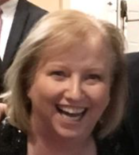
SHERRY STANTON
Email: Sstanton1602@gmail.com
Hometown: Rockville, MD

Instructional Objectives: It’s my objective to help singers find their healthiest, most resonant sound, so that we can ring the most chords for the longest time possible!

Instructional Qualifications: 30+ years SAI
20+ years directing, Certified 500+ director
Multiple time International quartet competitor

Chorus Affiliation(s): Capital Accord (Rehearsal Night: Tuesdays)
Quartet Affiliation:

Distance Willing to Travel: Doesn’t Matter

COACHING SKILLS:
SOUND
Blend and balance
Dynamic planning
Harmony accuracy and tuning
Posture/breathing
PVI's
Riser placement
Unit sound
Using vocal skills to enhance expression, emotion, storytelling
Using vocal textures
Vocal production

MUSIC STAFF MENTORING
Director skills training
How to give a PVI
Music staff training and development
Rehearsal planning and management
Section leader training

VISUAL COMMUNICATION
Characterization
Visual unity

KATE TOWNE
Email: kate.towne39@gmail.com
Hometown: Falls Church, VA

Instructional Objectives: Promoting the understanding of barbershop harmony.

Instructional Qualifications: Recipient of many years of high-level barbershop coaching. Assistant Director of Capital Accord Chorus, Member of 2019 International 4th Place Finalist Chorus Harbor City Music Company. Tenor of 2018 International Quartet Champion Lustre.

Chorus Affiliation(s): Capital Accord, Harbor City (Rehearsal Night: Tuesdays/Wednesdays)
Quartet Affiliation: Lustre (Rehearsal Night: Sunday)

Distance Willing to Travel: 0 – 50 miles

COACHING SKILLS:
SOUND
Dynamic planning
Harmony accuracy and tuning
Posture/breathing
PVI's
Unit sound

MUSIC
Music selection
Music theory

VISUAL COMMUNICATION
Characterization

OPEN DIVISION
Entertainment themes
Parody writing
Planning

GROUP MANAGEMENT
Getting your quartet started
Goal setting/Long range planning

TECHNOLOGY SKILLS
Computer skills

DONNA VINCENT ROA
Email: donnavincentroa@gmail.com
Hometown: Gaithersburg, MD

Instructional Objectives: In the taxonomy of learning, my instructional objectives for any course that I offer is Knowledge: Recall of specific information; Comprehension: Lowest level of understanding; and Application: Application of a rule or principle. The courses I design and deliver focus on the experiential and practical giving attendees a chance to "test" and "apply" the information in a safe and non-threatening setting. Students may be asked to demonstrate and perform during class settings to show concepts and principles in action. In my class design, I always ask: What behavior can the learner demonstrate to indicate that he or she has mastered the knowledge or skills specified in the instruction? And, a final objective is for the class to be engaging, fun, challenging, and offer something that transforms thinking and behavior.

Instructional Qualifications: I have a doctorate in Communications and master's studies in Theatre & Media Production, and undergrad specializations in English, Journalism, and Speech. In addition to teaching public speaking, radio production, advanced rhetoric/public speaking, and other communications classes at the university level, I have acted in six short films in Hollywood and have done voiceover work for the World Bank, EPA, USAID, Micronic Technologies, and other organizations. I have done MC work on stage, radio voiceover/announcing work as the "voice of the theatre", and have done numerous PSAs and commercial voiceovers. I have performed in 12 musical theatre productions and have a Level IV Designation as a Podium Master (Public Speaking). My professional training includes advanced scene study, television and film on-camera acting, soap opera on-camera acting, advanced acting, Broadway musical theatre, and television and film directing. I am a certified television producer and have had produced a short film that premiered at the Cannes Film Festival. I was also the MC in Harbor City's 2019 Finals Package presentation at the international competition. Published writer, working writer and editor, superior speaker, and a top 1% excellence ranking as a teacher in university settings.

Chorus Affiliation(s): Harbor City Music Company (Rehearsal Night: Wednesdays)
Quartet Affiliation: Pinnacle (Rehearsal Night: Friday)

Distance Willing to Travel: Doesn’t Matter

COACHING SKILLS:

OPEN DIVISION
Emceeing

GROUP MANAGEMENT
Effective communication
Effective meetings
Managing stage nerves
Marketing/PR
Motivating skills
Team building & management

TECHNOLOGY SKILLS
Graphics design
Webpage design

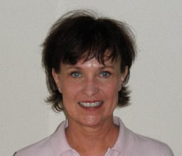
Cydney Wentsel
Email: cswentsel@gmail.com
Hometown: Bel Air, MD

Instructional Objectives: For every coaching session and class I facilitate, my primary goal is to support and expand the participants' understanding of and expertise in performing four-part a cappella in the Barbershop Style, specifically for BBS competition.

Since the best learning takes place in a positive environment, my secondary goal is always to make things fun and interesting!

Instructional Qualifications:
- BA in Education, MS in Counseling, advanced studies in administration and supervision
- Former educator, counselor and administrator (Pre-K - 12 and adult)
- Chorus singer (bari) in 8 small, mid-size and large choruses
- 20+ years directing 3 choruses (small and mid-size)
- Quartet singer (bari and tenor) 15+ top 5 finishes including Regional Champion
- Certified Music Judge
- Arranger
- Choreographer

Chorus Affiliation(s): Harbor City Music Company, (Rehearsal Night: Wednesdays)

Certified Judge? Yes/Judging Specialty: Music Category, although I am well versed in the other categories as well.

Distance Willing to Travel: 0 – 75 miles

COACHING SKILLS:

SOUND
Blend and balance
Dynamic planning
Harmony accuracy and tuning
Posture/breathing
PVI's
Unit sound
Vocal production

MUSIC
Arranging
Music selection
Music theory
Pedagogy
Sight singing

MUSIC STAFF MENTORING
Director skills training
How to give a PVI
Music staff training and development
Rehearsal planning and management
Section leader training
Sec
S VISUAL COMMUNICATION
Cha Characterization
Choreography designing & teaching
Costumes
Visual unity

OPEN DIVISION
Category requirements
Unity

GROUP MANAGEMENT
Chorus mediation
Effective meetings
Getting your quartet started

Lori Jo Whitehaus
Email: ljwhitehaus@gmail.com
Hometown: Millsboro, DE

Instructional Objectives: To inspire the singers to become all that they can be.
To empower women to unlock their own potential.
To encourage choruses to share their passion for music with the greater community.
To ring chords and love it.
To explore the many opportunities that come with members in SAI.

Instructional Qualifications:
Professional Educator since 1978 - Elementary and Secondary (BS & MS degrees)
Region 19 Faculty Member since @1985
Chorus Director since 1992
Attendance at (nearly) all Regional and International educational events since joining in 1978 - yes, 40 years
Life-Long Learner with Passion for Sharing Knowledge

Chorus Affiliation(s): Vocal Harmonix (Rehearsal Nights: Mondays)Ins
Quartet Affiliation: JewelTones (Rehearsal Night: flexible)

Distance Willing to Travel: Doesn’t Matter

COACHING SKILLS:

SOUND
Blend and balance
Dynamic planning
Harmony accuracy and tuning
Posture/breathing
PVI's
Riser placement
Unit sound
Using vocal textures
Using vocal skills to enhance expression, emotion,
storytelling
Vocal production

MUSIC
Music selection
Music theory
MUSIC STAFF MENTORING
Director skills training
How to give a PVI
Music staff training and development
Rehearsal planning and management
Section leader training

GROUP MANAGEMENT
Chorus mediation
Effective communication
Effective meetings
Goal setting/Long range planning
Motivating skills
Standing rules
Team building & management

Jennifer Williams
Email: DundalkDirector@gmail.com
Hometown: Millersville, MD

Instructional Objectives: I want to give back to the organization via chorus and quartet
education and motivation.
Singing and performing should be fun, easy and done in the healthiest way possible.
My approach is participant friendly with many opportunitities for engagement, interaction and fun.

Instructional Qualifications:
- Front line Master Director Dundalk Chorus
- Assistant Director Harbor City
- Visual Coordinator Harbor City
- Music Team member both choruses
- Member of International Judging Program in Visual Communication
- Personal voice and performance lessons

Chorus Affiliation(s): Dundalk and Harbor City Music Company (Rehearsal Nights: Wednesdays and Thursdays)
Quartet Affiliation: Happy Hour
Certified Judge? /Judging Specialty: Approved Candidate Judge Visual Communication

Distance Willing to Travel: Doesn’t Matter

COACHING SKILLS:

SOUND
Blend and balance
Dynamic planning
Harmony accuracy and tuning
Posture/breathing
PVI's
Riser placement
Unit sound
Using vocal textures
Using vocal skills to enhance expression, emotion,
storytelling
Vocal production

MUSIC STAFF MENTORING
Director skills training
How to give a PVI
Music staff training and development
Rehearsal planning and management
Section leader training

VISUAL COMMUNICATION
Choreography design & teaching
Costumes
Characterization
Getting it across the footlights
Make-up
Show planning
Visual unity

OPEN DIVISION
Category requirements
Entertainment themes
Emceeing
Humor
Parody writing
Planning
Script writing
Timing
Unity

MUSIC
Music selection

GROUP MANAGEMENT
Effective communication
Managing stage nerves
Motivating skills

TECHNOLOGY SKILLS
Computer skills

